1. Create table named customer with following columns

Customerid int,custname varchar(100),Phone int,Country varchar(100)

a. Add Primary key to customerid column with auto increment

option starting with 100

b. Add 10 records in customer table

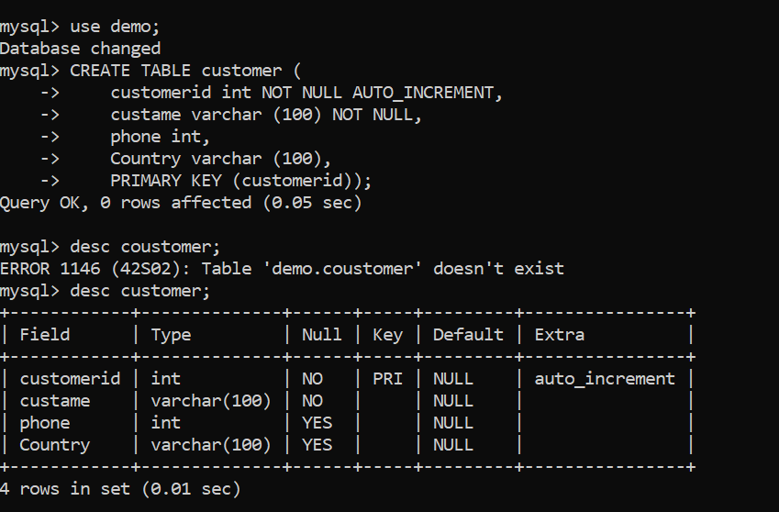

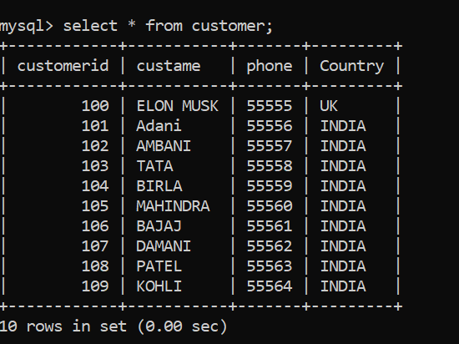

2. Create table named Order with columns

Orderid int,itemname varchar(100),price float,custid int

a. Add Primary Key to orderid column

b. Add Foreign Key to custid column references customerid column

in customer table

c. Add some records to orders table

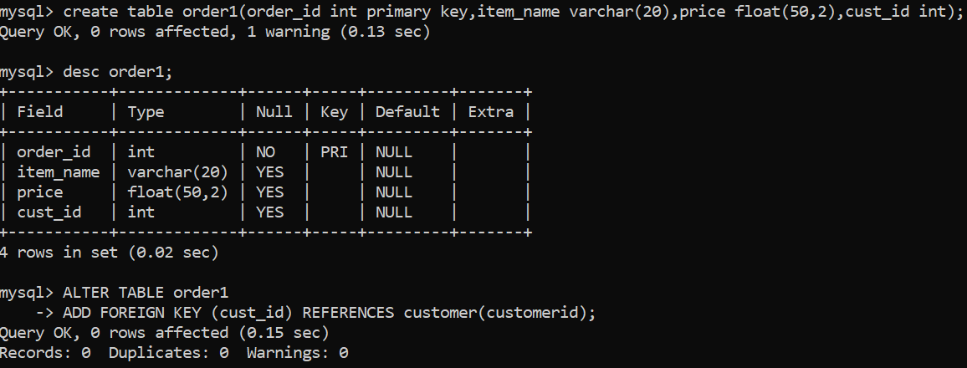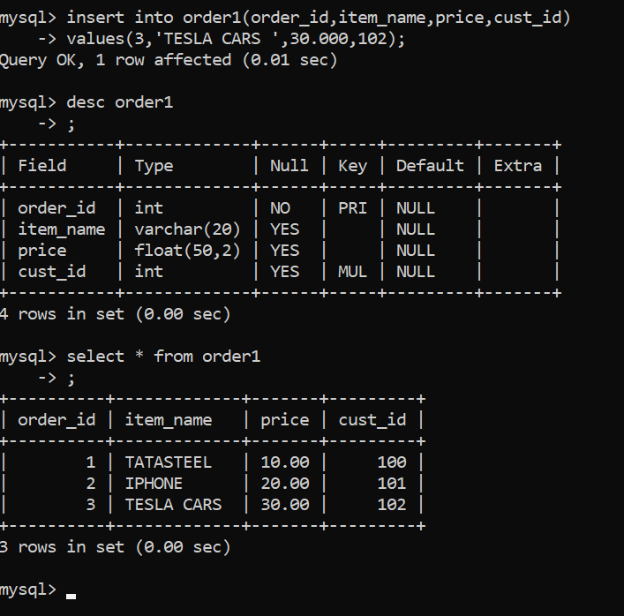

3. Display records from both the tables having matching rows

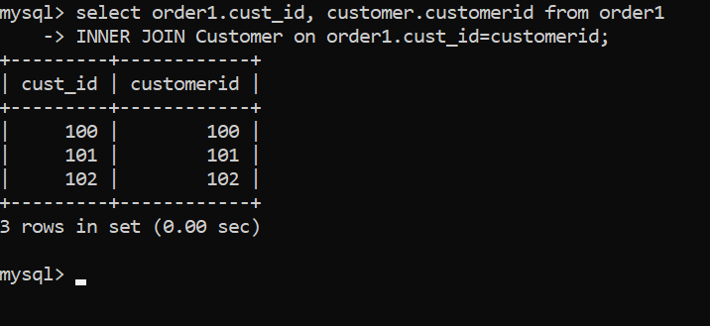

4. Display all records from customer table and matching records from both

Tables

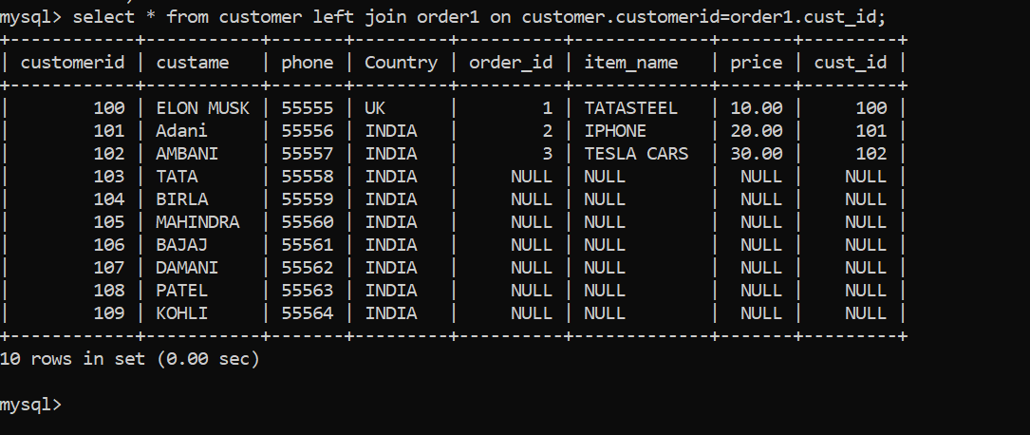

5. Display customer details where customer had ordered items with price

&gt; 100 using subquery from order table

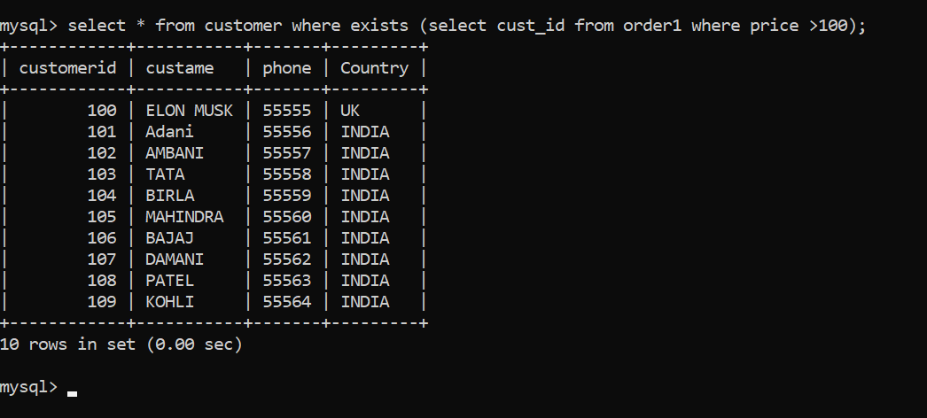

6. Display customers from customers table if and only if the customers

have order in orders table.

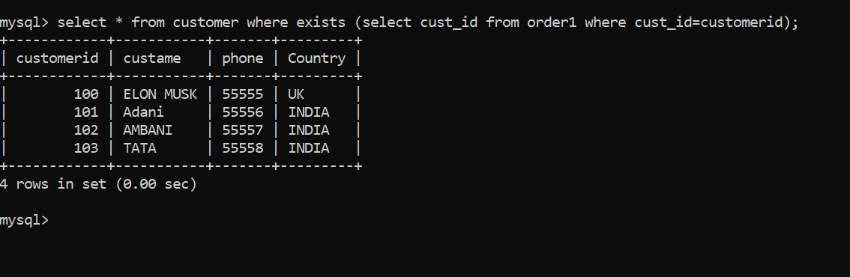

7. Create a replaceable view for customers table only for customers in India with check option. Add a new record in customers table through view

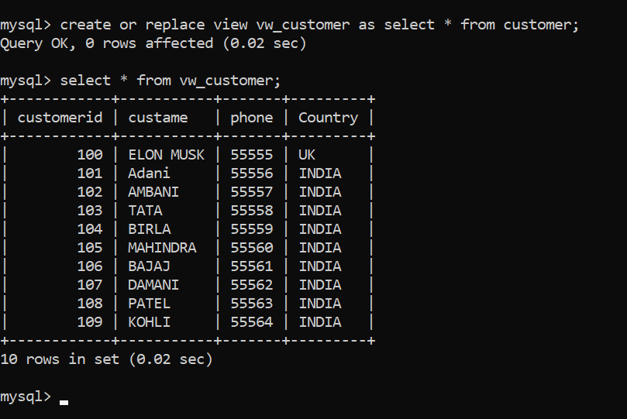

8. Insert 2 more records in orders table and give a savepoint Display the records in orders table Delete both newly added records. Display the records in orders table after deletion Use Rollback command to cancel the delete operation and display the orders table again

